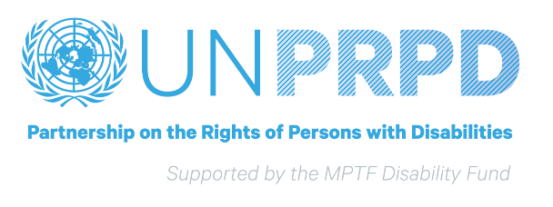

Brief Bio: Dr Ola Abualghaib
Dr. Ola Abualghaib was appointed Manager of the Technical Secretariat of the UN Partnership of Persons with Disabilities at UNDP in August 2019. Ola has over twenty years of experience working on gender and disability in development including in fragile and crisis affected settings in the Arab States, Africa and Asia. Previous to her appointment in UNDP she has been the Director for Global Influencing and Research at Leonard Cheshire Disability in London, UK. During the last 20 years she has worked with the UN system at global, regional and country level to support disability inclusive policies and programmes. She also served as the Vice Chair of the International Disability and Development Consortium (IDDC) and a board member of the Disability Rights Funds. Ola was recently featured in the Gender Equality Top 100 list of most influential people in global policy in 2019. She has a PhD on Social Protection from the University of East Anglia, UK.

